HOSTING A WEBSITE ON WINDOWS VIRTUAL MACHINE

**SUBMITED BY**

***M.J.SHAKHEEL AHAMED***

**ABSTRACT**

To host a website on windows virtual machine, we are required to install IIS (internet information service). The website will be available on the internet publicly as long as the machine is running. This situation can be avoided by using static IP addresses. In this article, we will only host a temporary website which will eventually vanish along with the associated VM.

**KEYWORDS:**

Virtual Machine(vm), IP address, IIS(Internet information service).

TABLE OF CONTENT

|  |  |  |
| --- | --- | --- |
| **S.NO** | **TITLE** | **PAGE.NO** |
|  | ABSTRACT | ii |
| 1 | INTRODUCTION | 4 |
| 2 | REQUIREMENTS | 5 |
| 3 | CREATE A VIRTUAL MACHINE | 8 |
| 4 | CONNECT THE VIRTUAL MACHINE | 12 |
| 5 | INSTALL INTERNET INFORMATION SERVICE | 15 |
| 6 | CREATING AND HOSTING THE WEBPAGE | 17 |
| 7. | CONCLUSION | 20 |

**INTRODUCTION:**

Internet Information Services (IIS) is a web server software package created by Microsoft for use with Windows Server operating systems. It's a powerful and flexible platform for hosting websites, web applications, and services. IIS primarily functions as a web server, capable of serving static and dynamic content to clients over the HTTP and HTTPS protocols. IIS includes robust security features such as request filtering, SSL/TLS support, and integration with Windows authentication mechanisms. t supports hosting various types of web applications, including ASP.NET, PHP, and Node.js applications, among others. IIS provides a user-friendly management interface, including the IIS Manager and PowerShell cmdlets, for configuring and managing web server settings. IIS includes performance monitoring tools that allow administrators to monitor server performance, diagnose issues, and optimize server resources.

**REQUIREMENTS:**

IIS (Internet Information Services) is a flexible, secure, and manageable Web server for hosting anything on the web. Its main requirements typically include:

* Operating System
* Hardware Requirements
* Software Dependencie
* Network Configuration
* Permissions and Security Setting
* Configuration Management
* Updates and Patches

**1.OPERATING SYSTEM**:

IIS primarily runs on Windows Server editions, but it can also run on some client versions of Windows like Windows 10.

**2.HARDWARE REQUIREMENTS**:

The hardware requirements depend on the workload and traffic the server is expected to handle. Generally, a server-class machine with sufficient CPU, RAM, and disk space is needed.

**3.SOFTWARE DEPENDENCE:**

IIS may require additional software components or modules depending on the specific features or services you intend to use, such as .NET Framework, ASP.NET, PHP, etc.

**4.NETWORK CONFIGURATION:**

Proper network configuration is essential, including IP address assignments, DNS settings, firewalls, and security protocols.

**5.PERMISSIONS AND SECURITY SETTING:**

Setting up appropriate permissions and security settings is crucial for protecting web applications and data hosted on the server.

**6.CONFIGURATION MANAGEMENT:**

Understanding how to configure and manage IIS through its management console or command-line tools is necessary.

**7.UPDATES AND PATCHES:**

Regular updates and patches should be applied to maintain the security and stability of the server.

CREATING A VIRTUAL MACHINE(VM):

**Follow these steps to create your virtual machine:**

**1.** Search for "**virtual machines**" in the search bar and select "**Virtual machines**" under Services.

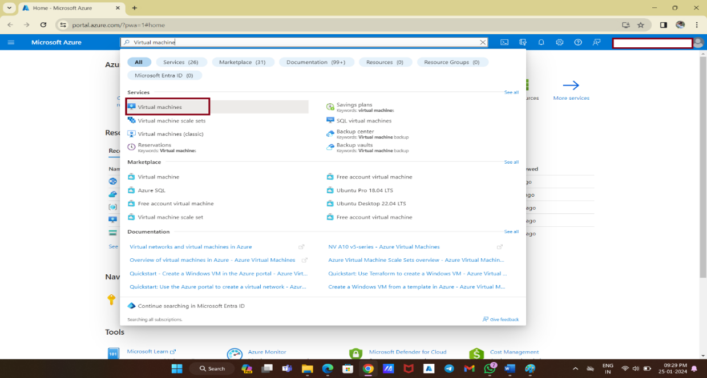

Azure virtual machines (VMs) are scalable cloud computing resources that operate similarly to virtual machines hosted in Windows Hyper-V. They offer processor, memory, storage, and networking resources, allowing you to start, stop, and manage them at will.

**2.** In the **Virtual machines page**, select "**Create**" and then "**Azure virtual machine**."

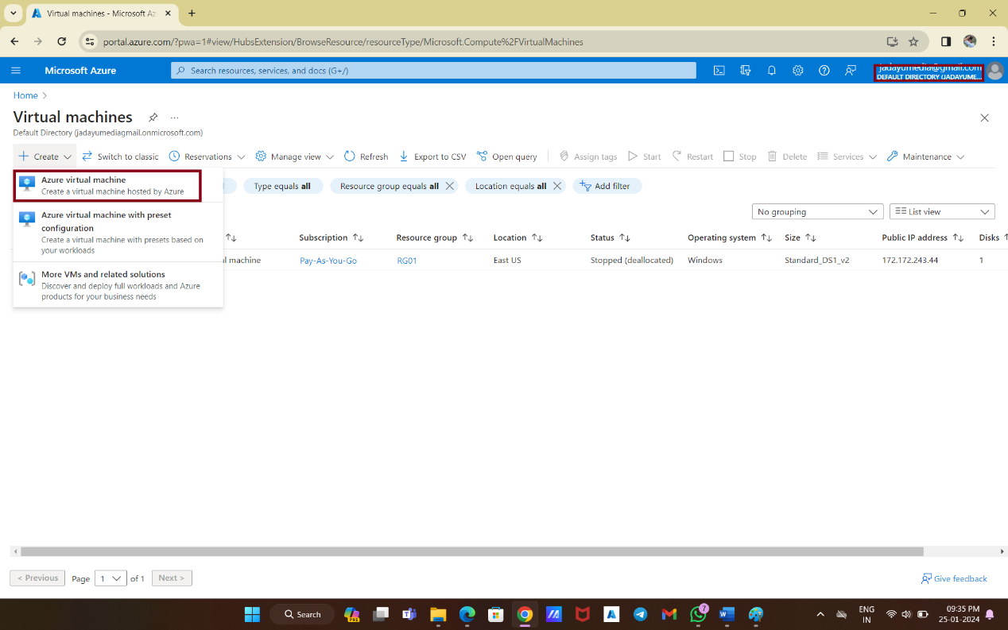

This will initiate the process of creating a new virtual machine on Azure.

**3.** In the "**Create a virtual machine**" page, leave the default values under **I nstance details** as they are.

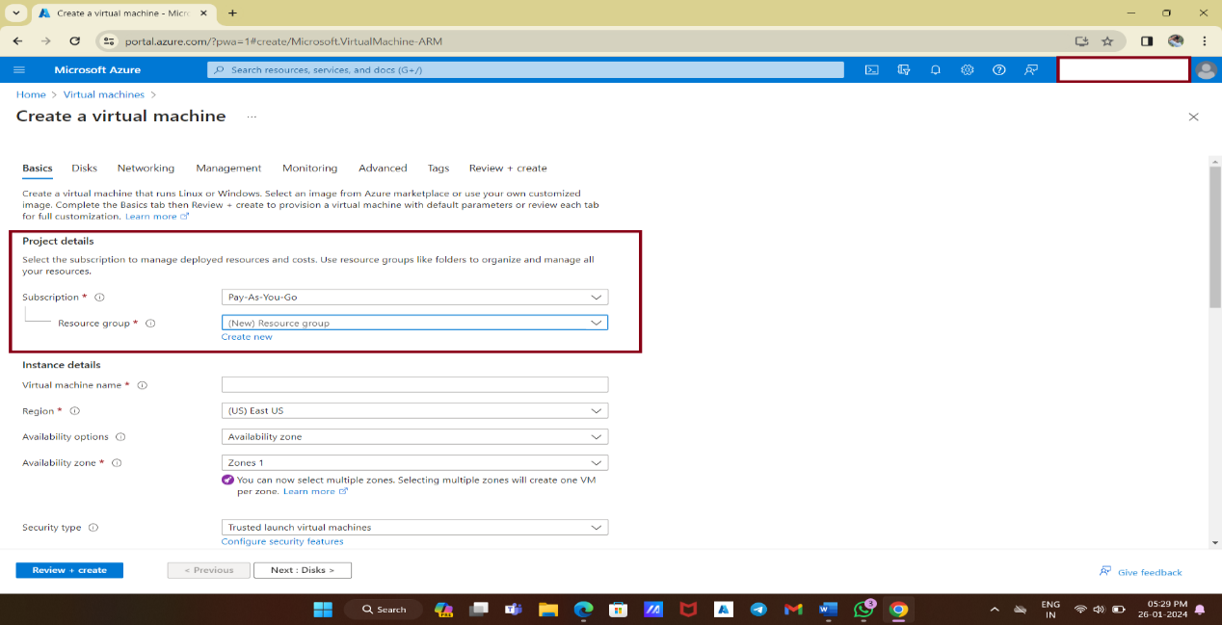

**4.** Choose a preferred name for your **virtual machine**, select a **region** that is closest to your location from the available global regions, and choose the **"[smalldisk] Windows Server 2019 Datacenter - x64 Gen2**" image. Leave the other options as default.

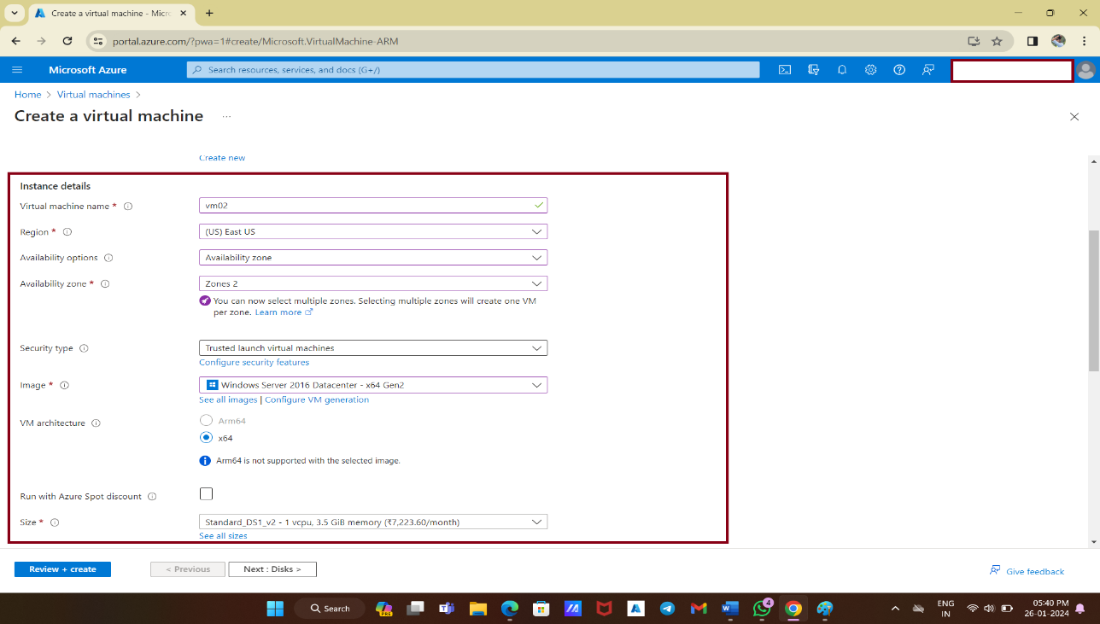

**5.** Under **Administrator accoun**t, provide a username and password of your choice. Remember that the password must be at least 12 characters long and meet the defined complexity requirements. For **Inbound port rules**, select "Allow selected ports" and choose **RDP (3389)** and **HTTP (80)** from the drop-down menu. Leave the remaining settings as default and select the "**Review + create**" button at the bottom of the page.

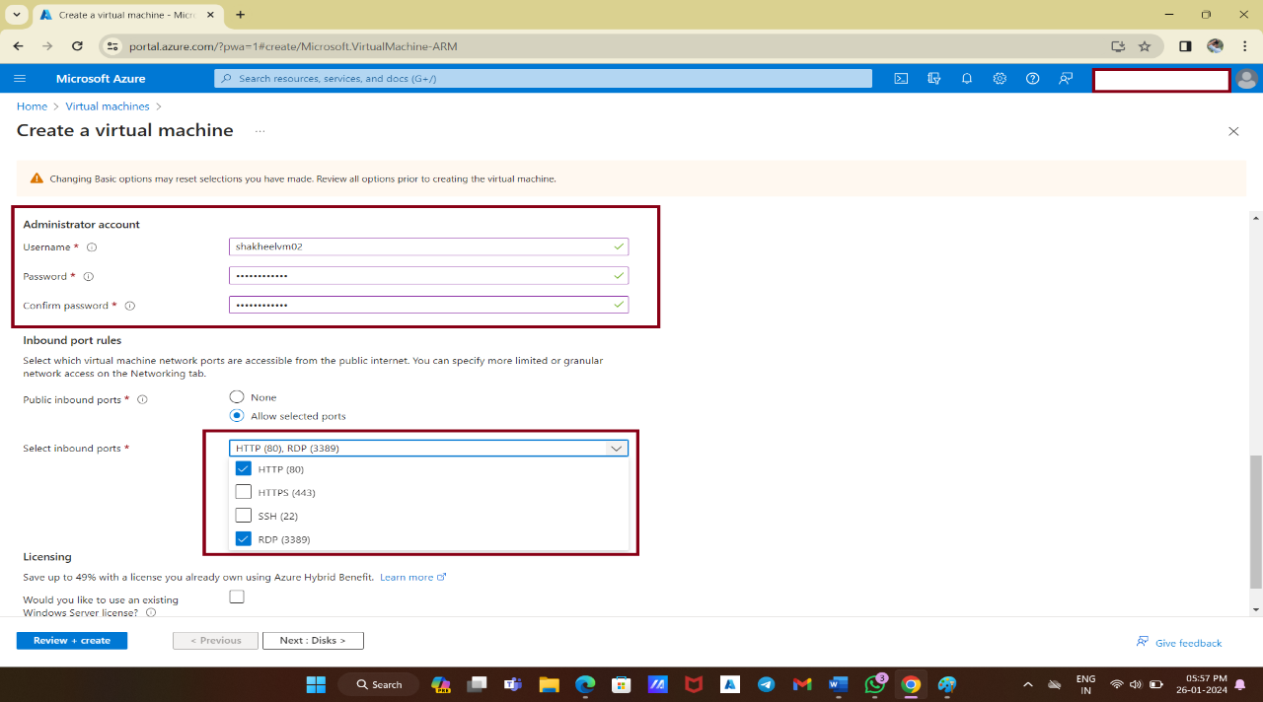

**6.** After the validation process completes, select the "**Create**" button at the bottom of the page to begin the deployment of your virtual machine.

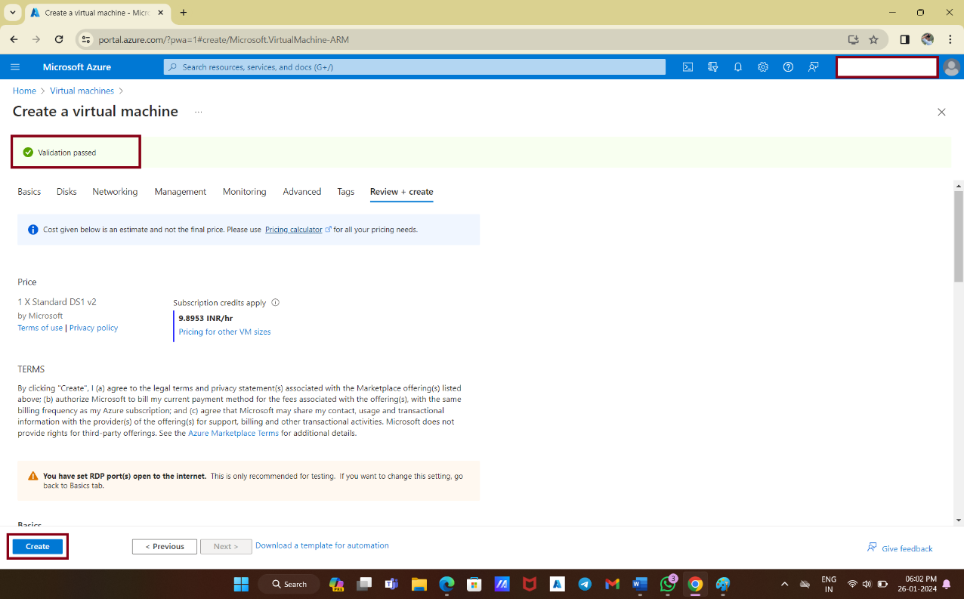

**7.** Once the deployment is complete, select "**Go to resource**" to access your newly created virtual machine.

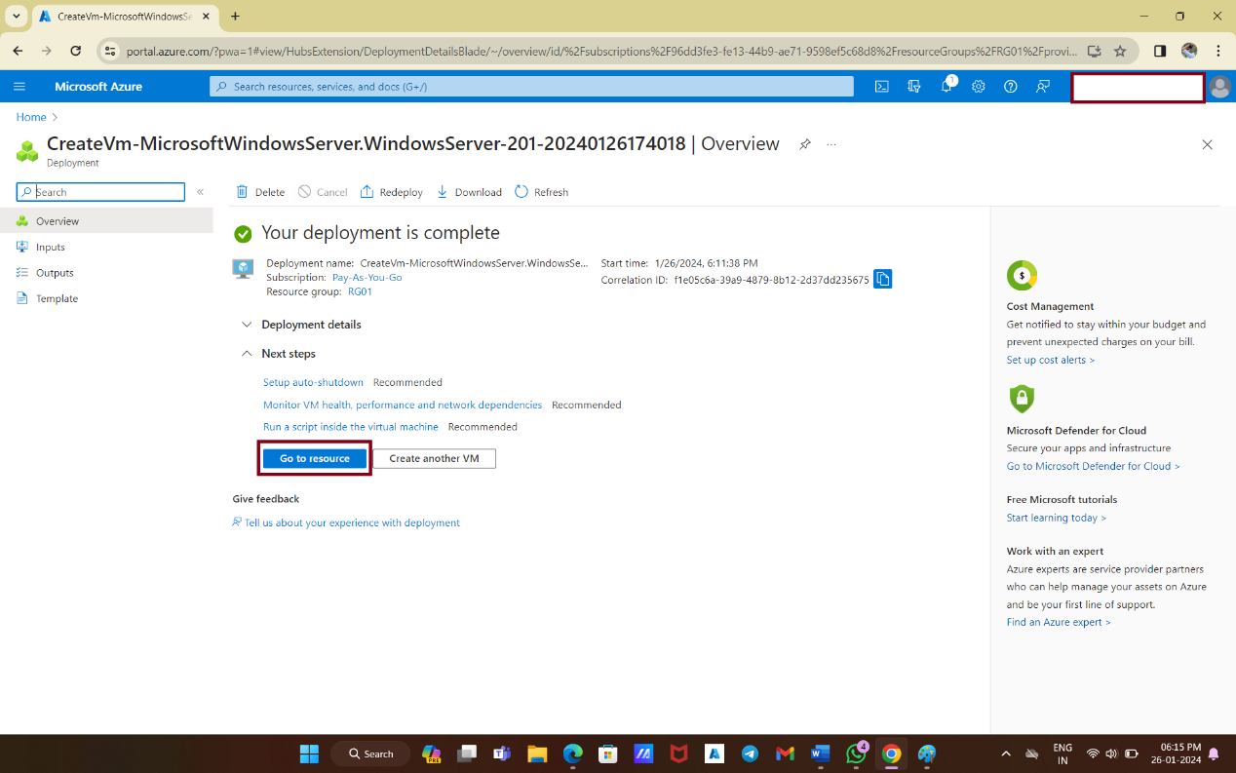

**CONNECT TO THE VIRTUAL MACHINE(VM)**

Now that your virtual machine is up and running, you need to connect to it using Remote Desktop. Follow these steps:

1. On the **overview** page of your virtual machine, select "**Connect**" and then "**RDP**."

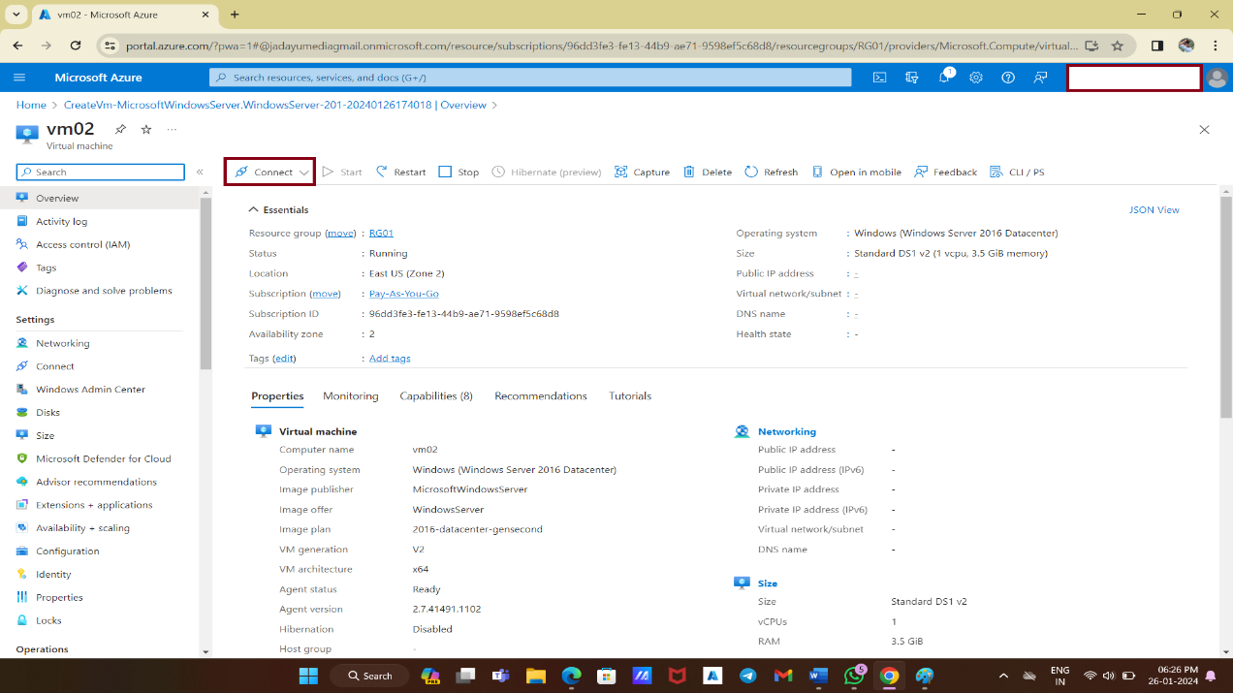

2. In the "**Connect with RDP**" tab, keep the default options for connecting by IP address and over port 3389. Click "**Download RDP file**" to retrieve the Remote Desktop Protocol (RDP) file.

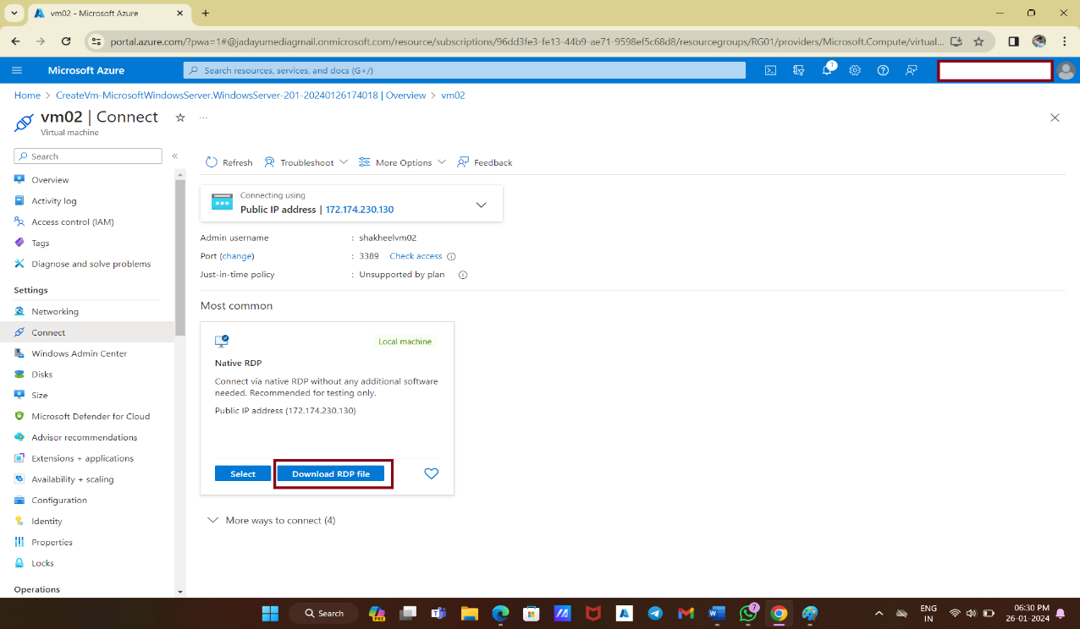

3. Open the downloaded RDP file and click "**Connect**" when prompted.

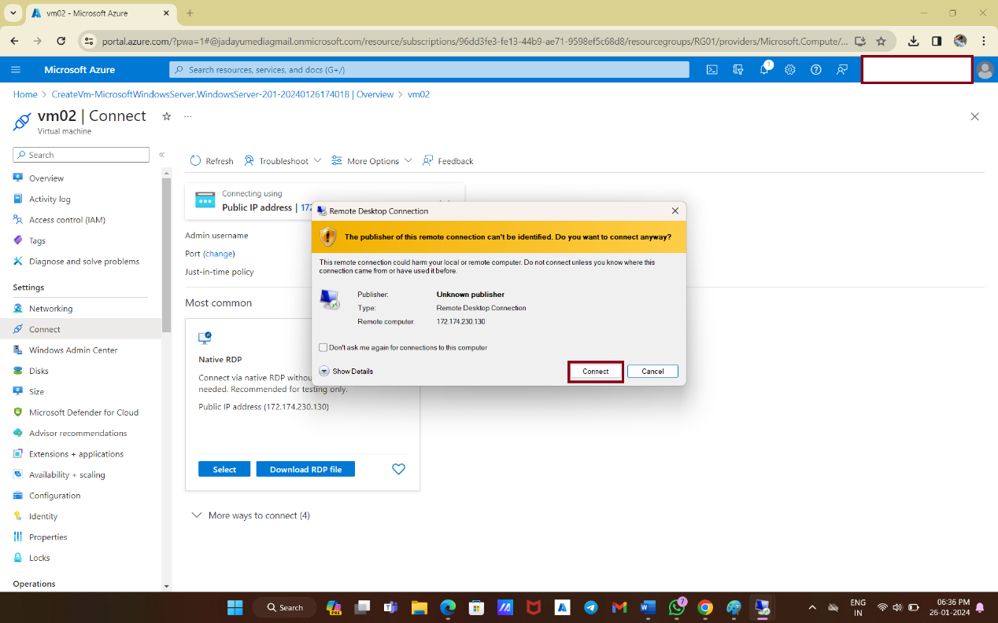

4. In the **Remote Desktop Connection** window, enter the username as localhost\username (replace "username" with the username you provided during the virtual machine creation process). Enter the password you created for the virtual machine and click "**OK**."

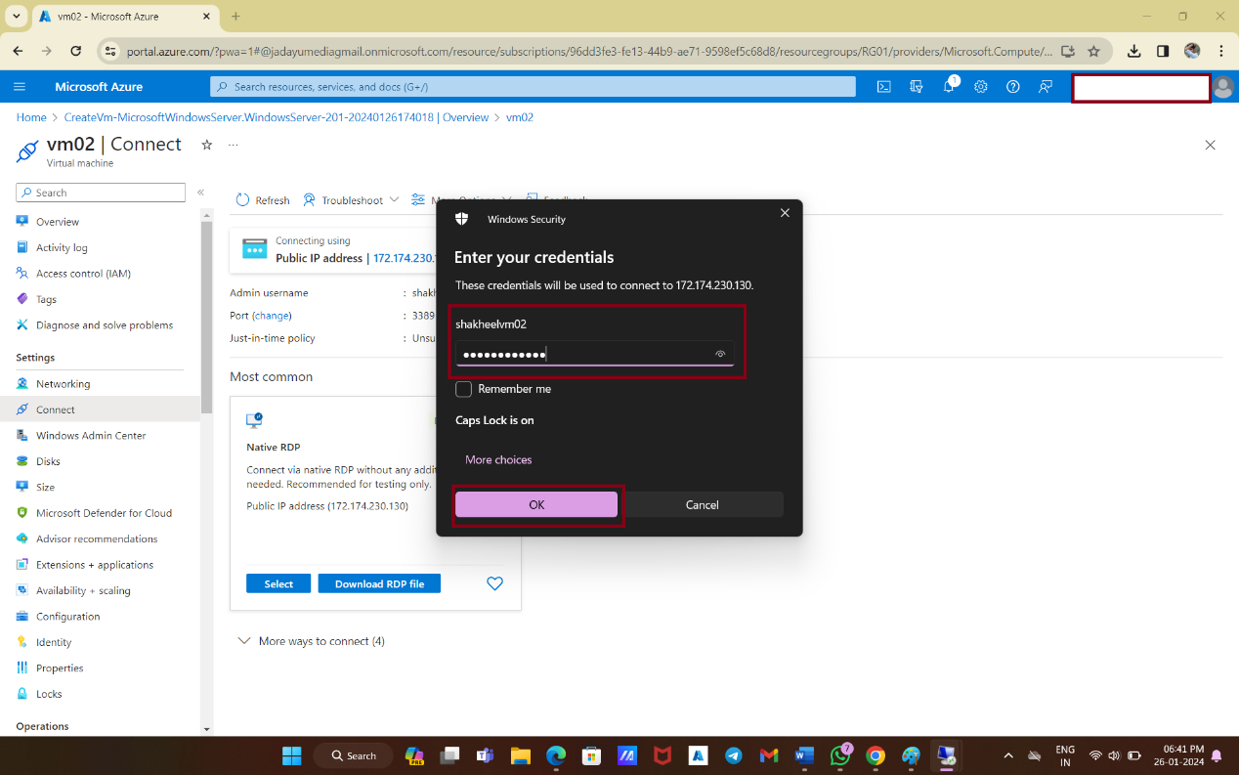

8. You may encounter a certificate warning during the sign-in process. Click "**Yes**" or "**Continue**" to proceed with the connection.

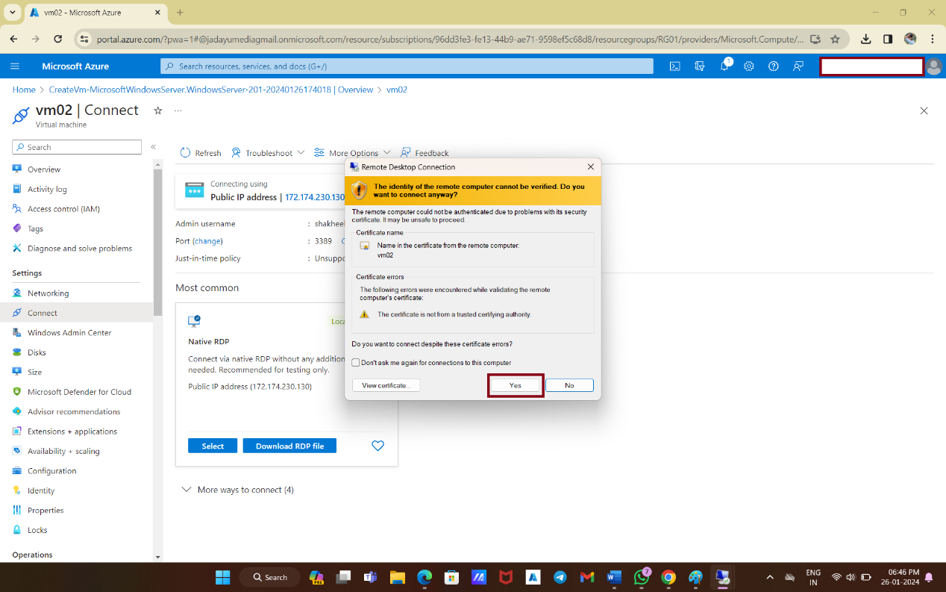

9. Then,You have successfully created your first virtual machine on Azure.

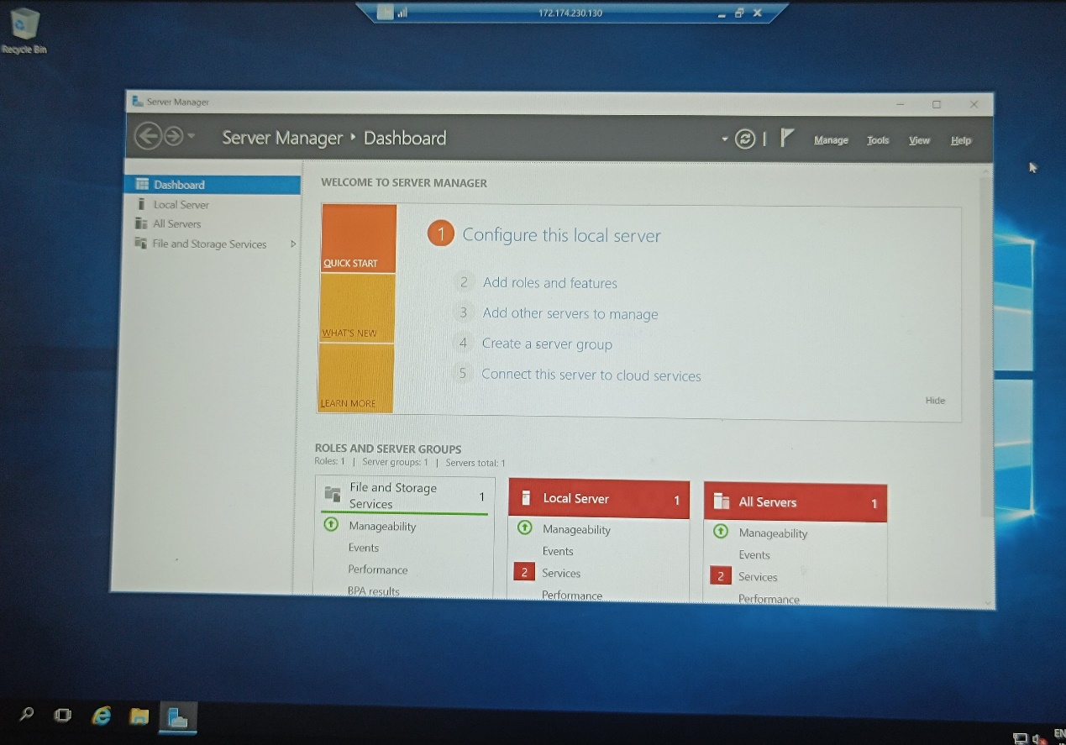

**INSTALL INTERNET INFORMATION SERVICE:**

1.Go to the **server manager** then **add Roles and Features Wizard.**

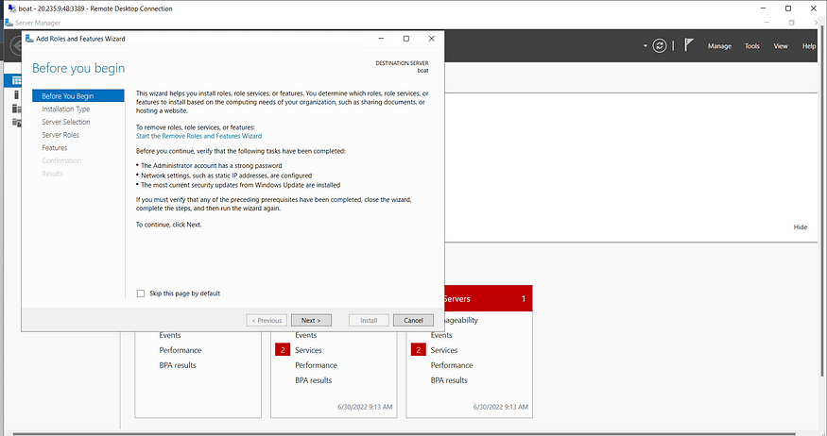Continue by clicking **Next**untilyou get to **‘Server Roles’.**

2.Select **Web Server (IIS):**

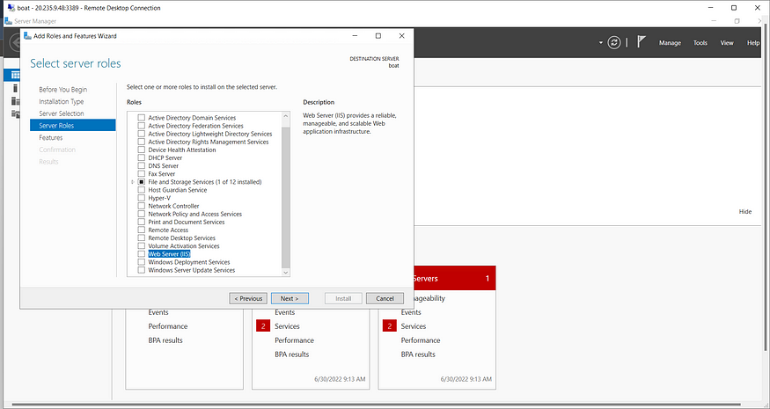

3.Install **Web Server(IIS):**

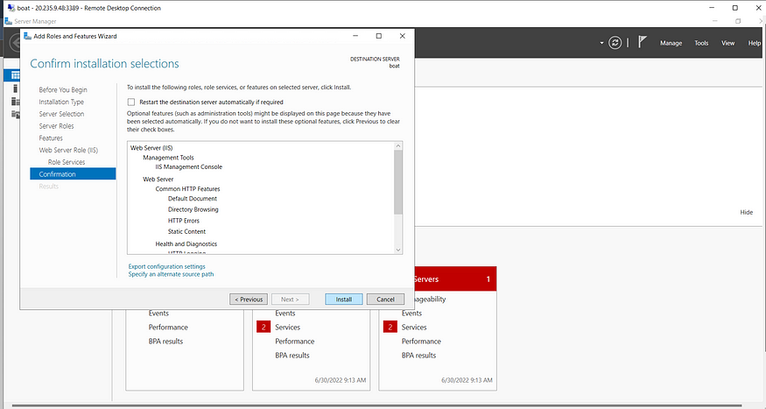

Check the public IP address of VM on the browser to assure safe installation of IIS.

**CREATING AND HOSTING A WEBPAGE:**

1.Look for the **Internet information services manager** and select your VM.

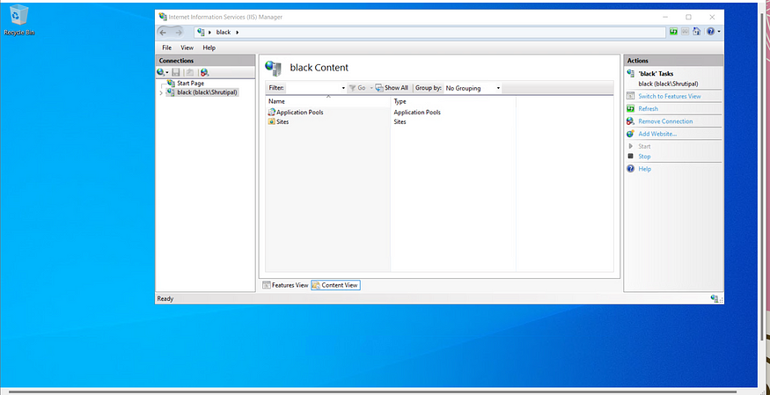Now select **Sites** and then **Add Website.**

2.Fill in your desired site name. The physical path is primarily ***C:\inetpub\wwwroot****.*Extend this path by creating another folder in the wwwroot folder. This makes final physical path pointing the location of this new folder.

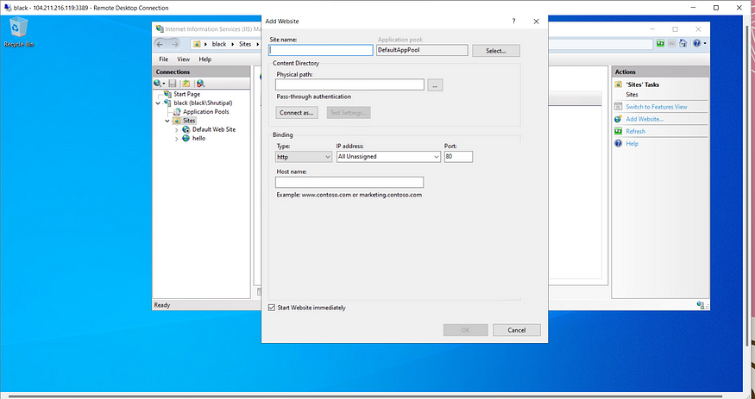

3.Make sure the **port is 80** of this site. Change the binding port of the default Web Site to 8080. *[Note: Port 80 is the default path].*Also, stop the default Web Site.

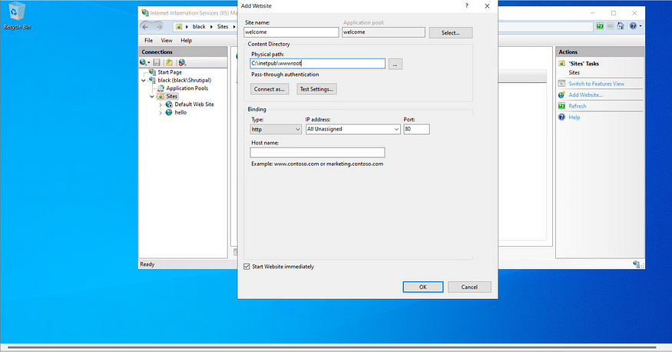

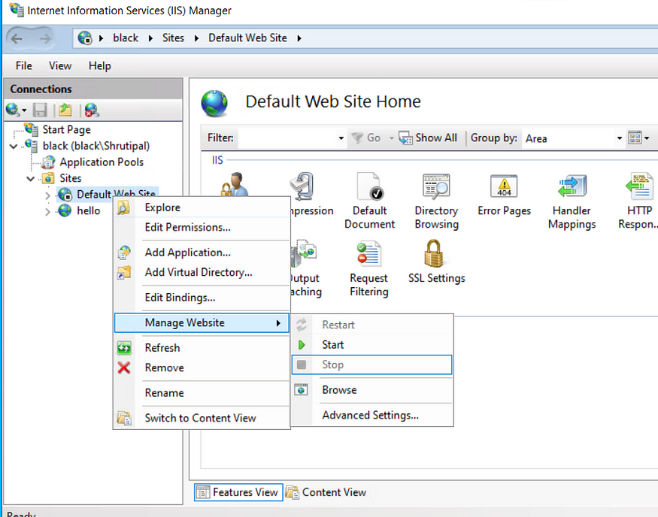

4.Next locate and go to the new folder inside wwwroot. Create an html file named **‘index.html’**. Write some html code and save it.

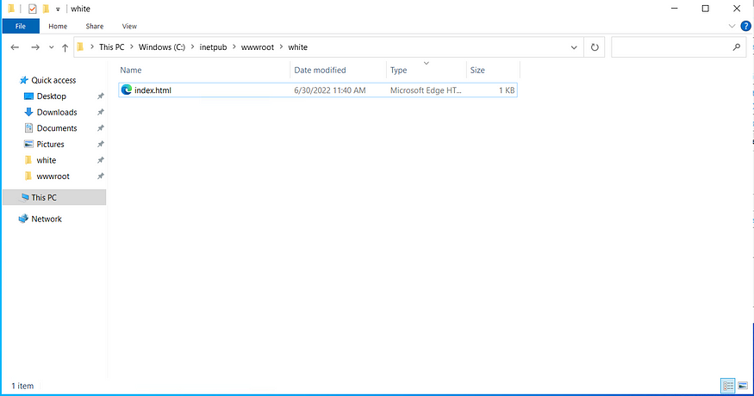

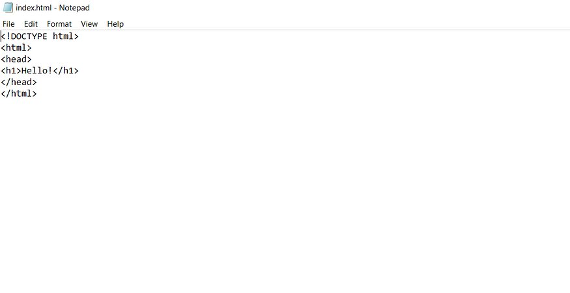

5.Go to the browser and refresh your VM public IP address. This page should show the content of the index file. *[Hello! in my case]*

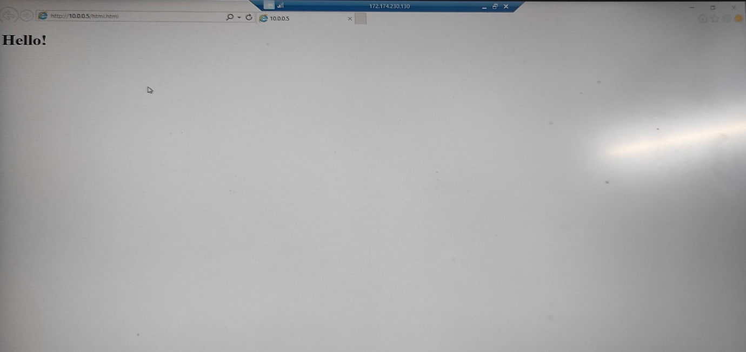

Your web page is up on internet and running on IP address of Virtual Machine.

**CONCLUSION:**

If your web hosting requirements aren’t directly supported by the Azure Web app platform, you can leverage virtual machines to customize and control every aspect of the web server. [You can create, configure, and manage virtual machines on Linux and Windows that host web apps](https://learn.microsoft.com/en-us/training/paths/deploy-a-website-with-azure-virtual-machines/).